**Environment:** Analysis was performed on TEST environment.

General info:

|  |  |  |  |  |  |
| --- | --- | --- | --- | --- | --- |
|  | **Host** | **Type** | **IP** | **Hosted Applications** | **Ports** |
| STAGING | EPUAKYIW1686T1 | VM | 10.17.172.226 | EPUAKYIW1686T1.kyiv.epam.com | 8080, 4444 |

System resources (TEST env):

|  |  |  |
| --- | --- | --- |
| **CPU, GHz** | **Memory, Gb** | **Disk size, Gb** |
| 2 | 8 | 100 |

**Test scenario**

There is a combined scenario which is to include the scripts:

• Task 4 (admin)

• Task 5 (editor)

• Task 6 (anonymous)

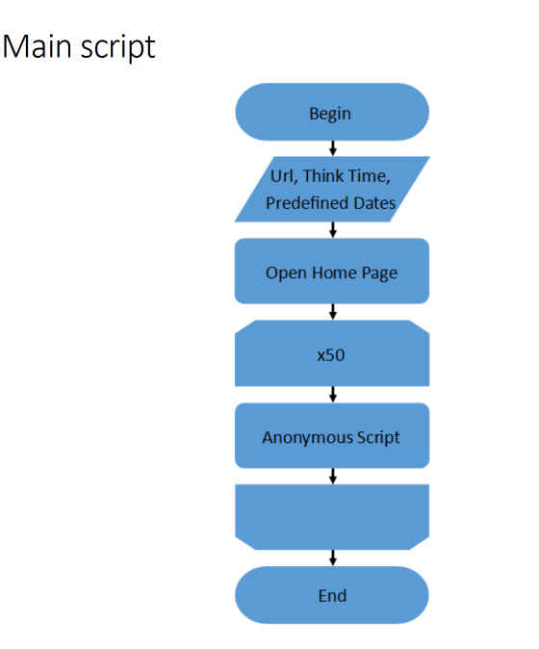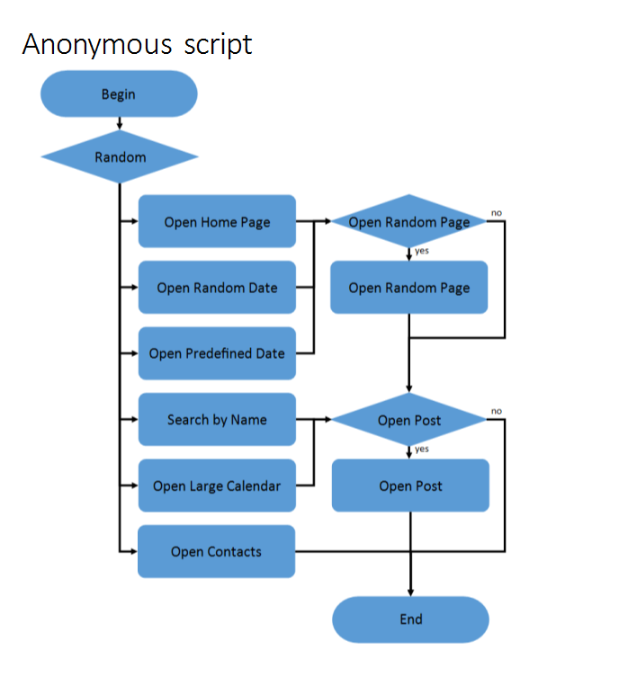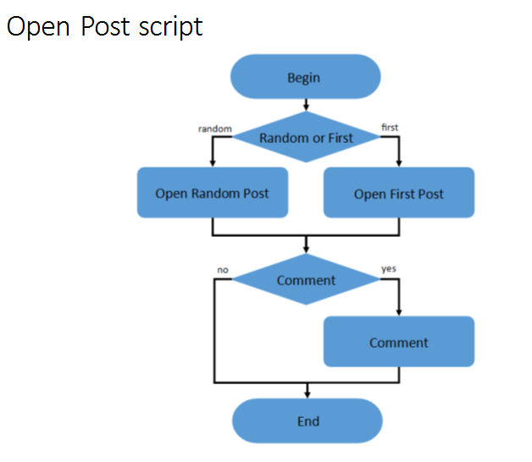

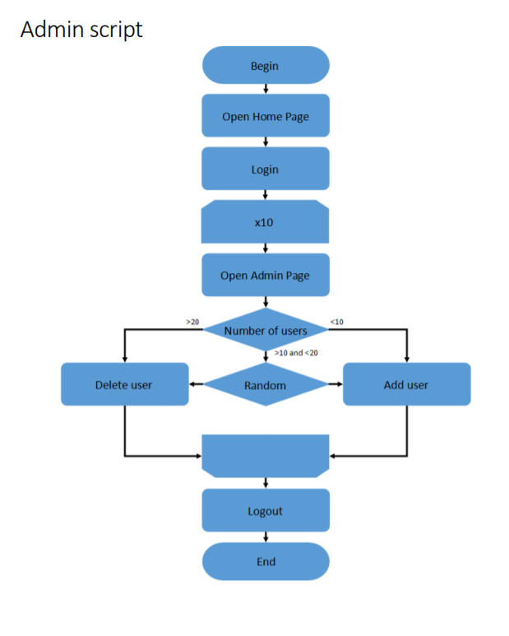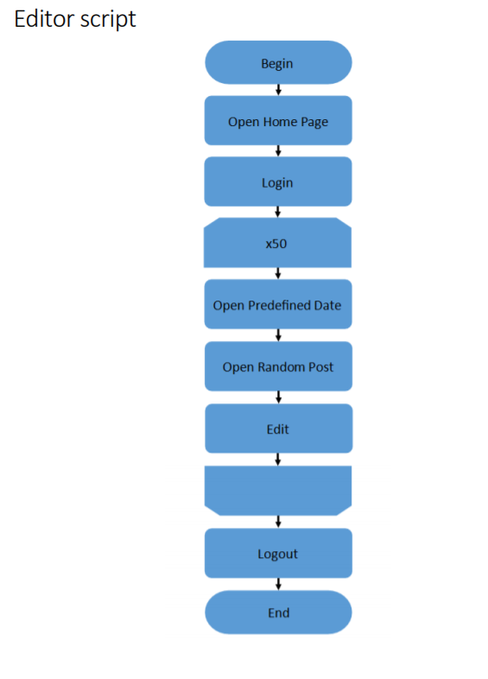

**Test conditions**

|  |  |
| --- | --- |
| **Transaction** | **Condition for anonymous script** |
| open home page | 15% |
| open random date | 10% |
| open predefined date | 30% |
| search by name | 30% |
| open large calendar | 10% |
| open contacts | 5% |
| open random page | 50% |
| open post | 80% |
| open random post | 65% |
| open first post | 35% |
| add comment | 20% |

**Test Setup**

|  |  |
| --- | --- |
|  | Condition |
| number of virtual users | Up to 35 – Anonymous  2 – Admins  2 – Editors |
| ramp-up period(sec) | 400 – Anonymous  30 – Admin  30 ­­­– Editor |
| duration(sec) | 600 |
| think time (sec) | 3-5 |

**Test Summary**

1 The smoke test shows that even with such load we have problems with several transactions.

Firstly, its Open Home Page transaction.

Then Open Admin Page transaction and Open First Post transaction.

**Recommendation**

1 Possibility to increasing CPU power.

2 The admin page is used not so often however the main page is opened by all users.

3 Desktop Adapter Packets graph shows that on low load could be a memory leak.

**Results: graphs and tables(for more details open dashboard HTMLReport > index)**

1 Statistics

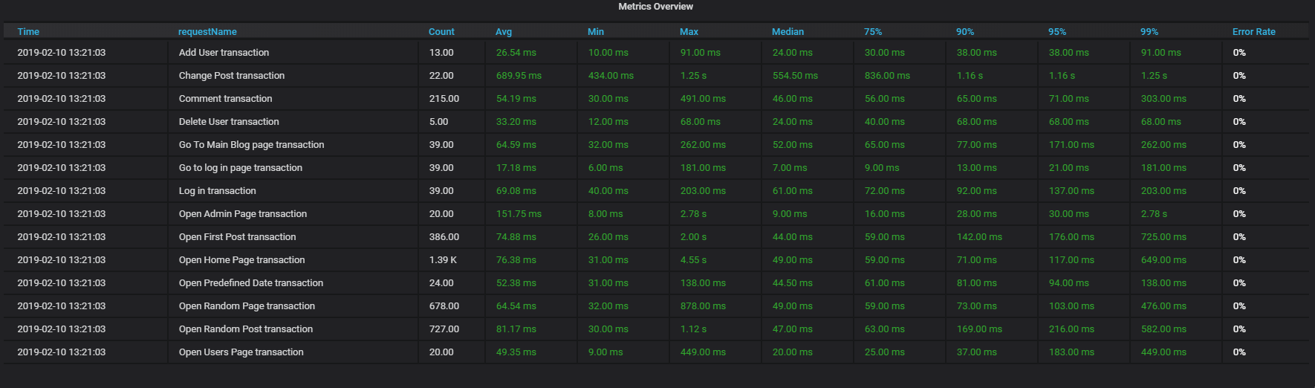

2 Number of active threads vs throughput graph

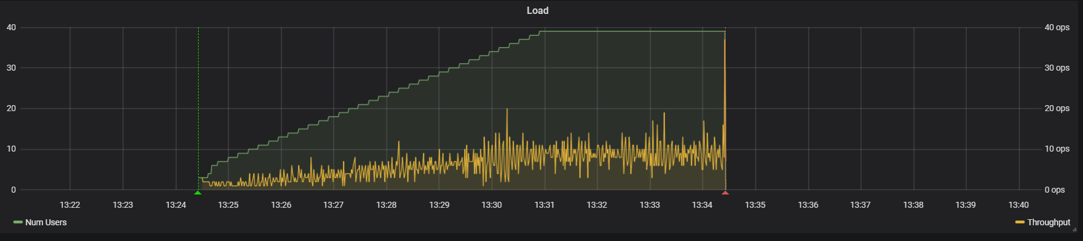

3 (CPU,Memory,Network) graphs

